Veo times
Pg.3
BANGLORE TIMES

ENVIRONMENTAL ISSUES
Bangalore is fastely becoming a great city. But during theses changles we are not bothered about environment whitefield the fastest growing place is bearing dirty. So I request each and every person to spread awareness of a clean and beautiful
By
Abhishek Ravi Kiran
7- b NCFE

SPORTS
CRICKET
Shikar dhawan is for now injured so murali vijay for Sri Lanka tour. Injures murali vijay is out for Sri Lanka tour . His place will be taken by Shikar dhawan
WEBSITE
Varun enterprisesorg has got a new icon
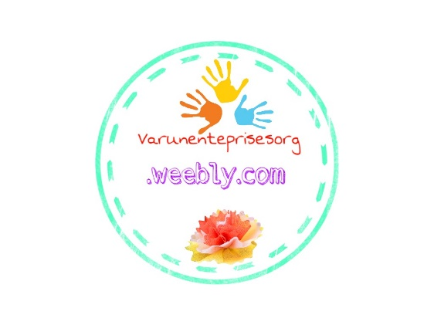

VEO TIME
Pg. 5
ARTICLE

What is os? Os is called operating system. It is a set of program in which we use computer. Without os there is nothing. There are two types of os. The first one is for devices like phone, tablet. Other is used for pc, mac, laptop, and notebook. They are different types of operating system like mac, windows Ubuntu etc. Now people use many and high speed os like remix , memu etc. now mac build a new os or a new update called mac os high sierra which is best of mac . Windows also introduced window 10 pro which is a professional version of windows 10
. They is much thing’s we need to learn to build a small part of operating system. We need to learn a lot of programming like jass, c++, c#, java script etc. this is very important to not make mistake while doing a programming. They are different types of os in phone etc. the origin are iOS and android. The iOS are iOS 11, ios9, etc. in android they are sandwich, icecream , jellybean, lollypop , marshmallow , nougat , and present and poplar the ‘android o’.
People might know about the famous android os it is poplar all over the world even people of India use them. Many phone turn their operating system by a system update once in a month. It take more than 23,000 mb data to transform a jellybean os to lollypop os .
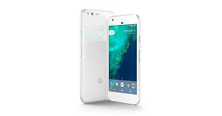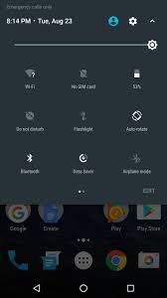

Veo times
Pg 6
Sports

ICC Women’s World Cup 2017: England hold nerves to win by 2 wickets, enter final

The match changed hands more than once and in the end, it was England who won it. The first semi-final of the ICC Women’s World Cup 2017 saw some nail-biting cricket and severe emotions between England and South Africa as both teams battled for a spot in the final. South Africa did well to take the match to the final over in which England needed three runs.
But as soon as Anya Shrubsole cracked a cut off the penultimate ball of the match, South African players shrank on the field with their hands on their heads. Left with tears in their eyes, the women looked on as the home team ran towards the two batswomen and cheered after making the final at home.
The home team chased down a target to 219 runs after losing eight wickets in a chase which they should have completed easily after the brilliant start and later a brisk 54-run innings from player-of-the-match Sarah Taylor.

Your article in veo times

You get a chance to send your article to veo time. Just sent your article with your name, designation, etc. topics are environment, computer and library. It should be less than 140 words. Sent to veo2395@outlook.com.

