Veo times
DATE - 19/7/17 VOLUME -1 RUPPEE – 4 pg 1

A TECH IN FEATHER

IOS COMING THIS Fall
Apple has introduced iOS 11 which will be coming this fall. IOS 11 is packed with full of surprises, including recording screen, new control Centre, and most importantly drag and drop. Drag and drop is a brand new feature, coming from iOS
Onwards. It makes app recording so easy, and its functions can be implemented in all other apps like A.R kit, i.e. , augmented reality kit , is given to all iOS developers . Which bring many apps like Pokémon go, etc, Very optimized. Thanks to iOS 11, you can do a lot more things with an IPAD and iPhone than ever before. Apple has also provided iOS 11 publics beta for testers to test iOS 11. For more information for enrolling, visit www.beta.apple.com
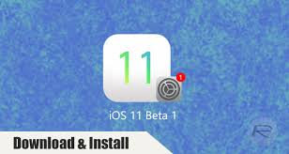
By,
Aakaash .s.s
7th b
n.c.f.e.
An apple developer
Founder of AAV corp - aavcorp.weebly.com

Google Allo v14 brings features

While we still await the much-delayed Web client of Google Allo, version 14 of the messaging app has now started rolling out for Android and brings message reactions to the platform. Currently, the latest update is not showing up for us but it is expected to be rolled out by the search giant in phases to the users. Continued on pg 2
VEO TIMES
PG 2
A TECH IN FEATHER

Now, just like on Facebook Messenger, users can give emoji reactions to particular messages within the chat and once there are multiple reactions, the count of the reactions starts showing up beside the message. Amit Fulay, head of Google Allo, announced the new feature in his tweet saying, "Latest #Google Allo version out today! You can react to messages in chat (tap the heart to like them)"
Notably, unlike Facebook Messenger, Allo users can only react to messages with a heart-shaped emoji as of now. Fulay has suggested that there are more "under-the-hood enhancements" that come with the update but we will have to wait to figure out other notable additions. For now, there's now word on when the updated app will hit iOS.
By gadget 360
VARUN ENTERPRISES ORG RENOVATION FOR 17-18

Varun, founder of varunenterprises org has introduced some new features for the year 17-18. As it is the first anniversary of varunenterprises org and the founder has introduced new newspaper called ‘veo time ‘it is new newspaper which has realsed this month. The new logo is very nice.

VEO TIMES
Pg. – 3

PUZZEL AND COMICS

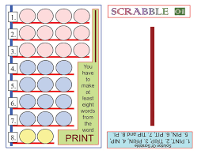 meaning for the day – uber 